**Boyd, Arthur (1920-1999)**

Arthur Boyd is widely recognised as one of Australia’s greatest artists. He was born in Melbourne to Merric and Doris (née Gough) Boyd, into a family that was unusually creative and unconventionally religious. Their home at Murrumbeena became a meeting place for artists and intellectuals during the war years. Arthur Boyd began his artistic career with a considerable knowledge of art, buoyed by the previous generation’s enthusiasm for European cultural life and ideas. Although associated with artists surrounding *Angry Penguins* magazine, Boyd did not take part in contemporary debate over the role of art in society. Arthur Boyd’s work is beautiful yet haunting; grotesque yet disturbing; historical and contemporary. He maintained dialogue with great masters of European art, and yet remained a visionary of the future.

Boyd’s grandfather, with whom he lived on Port Phillip Bay from 1936 to 1939, encouraged his career. During that time, Boyd developed his self-discipline, powers of observation, work ethic, and independent dialogue with the Australian landscape. In 1936 he met Yosl Bergner, a Polish Jewish painter who exerted a profound influence on Boyd’s development. The impending disaster in Europe and the threat to the Jews were still remote to Australians in 1938, but Bergner’s life experiences enabled him to act as a sort of prophet of doom. His direct experience of European expressionism allowed him to introduce the work of Edvard Munch and Oskar Kokoschka to Boyd. The Russian émigré Danila Vassilieff also acted as a catalyst for Boyd to experiment widely.

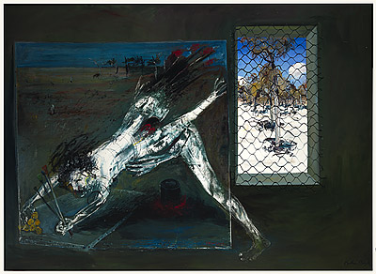

Arthur Boyd, *Paintings in the Studio: ‘Figure Supporting Back Legs’ and ‘Interior with Black Rabbit’,* 1973-4, oil on canvas, 313.5x433.2 cm, National Gallery Australia, Accession No: NGA 75.3.118.

Although Boyd was not old enough to experience armed combat, the thousands of drawings he made during his time in the army underpin the proliferation of his painted work from 1946 to 48. In these powerful paintings, the Australian landscape forms the backdrop for biblical narratives which are metaphors for the world war and the Holocaust. Boyd incorporates references to literature and the history of art, particularly the work of Pieter Breughel and Hieronymus Bosch. Paintings such as *The Mockers* (1945) and *Melbourne Burning* (1946-7) became iconic in Australian art. These were followed by landscape paintings of the arid Wimmera area. Boyd’s trip to central Australia resulted in brooding and intense ink drawings of detribalised Aboriginal people. *The Bride* (1957-59) series, uniquely conveying the wretched plight of Aboriginal people, was the consequence of sketchbook drawings.

In 1959 Arthur Boyd and his wife Yvonne left Australia for London. Having seen old master works in reproduction, Boyd revelled in the National Gallery. He travelled the continent visiting museum collections. His Aboriginal people transformed into lovers: *Nude with Beast* (1962-3) series was based specifically on Titian’s rendering of Diana and Actaeon, a story of suffering and punishment, human fallibility and temptation. Collaborative projects with historian T.S.R. Boase and Australian poet Peter Porter provided inspiration and sustained direction, expanding Boyd’s imagery. For the next 20 years, moving between England and Australia, he painted prolifically. His projects addressed the role of the artist, environmental issues, and war. Boyd’s home in Bundanon, New South Wales inspired some of Australia’s finest landscape paintings. The *Caged Painter* series (1970s) by contrast, comprises searing images of the role of the artist in society.

**References and Further Reading**

Phillip, Franz, (1965) *Arthur Boyd: Art and Life*, London: Thames and Hudson London.

McKenzie, Janet. (2000) Art*hur Boyd, Art and Life*, London: Thames and Hudson.